|  |  |  |  |
| --- | --- | --- | --- |
| **Mobile Applications and Web Development -IS4904(Practical)** | | | |
| **Student Name:** | **Student ID:** | | **Section:** |
| **Assignment (Exploring the Health Informatics Stack)** | | | |
| **Date: 5th March 2024** | | **Max Points:** | |

**Submission Guidelines:**

Submit the essay and Dart program files via the designated submission platform.

Ensure code is well-commented and follows Dart style conventions.

**Question** 1: Introduction to Null Safety in Dart

**Objective**:

To reinforce understanding of the concept of null safety in Dart and its significance in writing reliable code.

**Tasks**:

1. Write a short essay explaining the importance of null safety in Dart programming(two lines max).

Null safety is very important in darts programming to help ensure the reliability of the code by preventing (null) references and errors. By using null safety//

2-Create a Dart program that demonstrates the difference between nullable and non-nullable variables. Use both nullable and non-nullable variables in your program and explain how null safety affects their usage.

\\NonNullableString is a non-empty variable. An empty value cannot be assigned to it.

nullableString is a nullable variable. It can contain a string value or null.

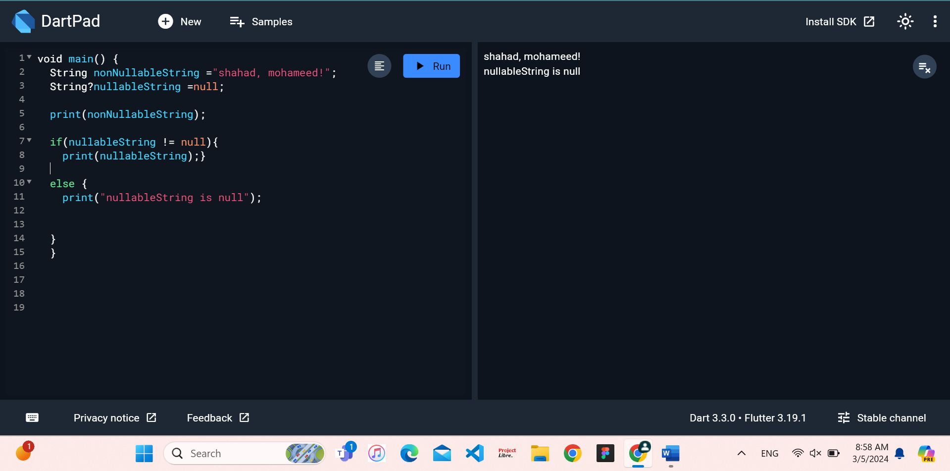

**Question** 2: Handling Null Values in Dart

**Objective**:

To practice working with nullable types and null-aware operators in Dart to effectively handle null values.

**Tasks**:

1. Write a Dart program that demonstrates the use of null-aware operators (??, ?., ??=) to handle null values. Include examples of each operator in your program and explain their purpose.
2. 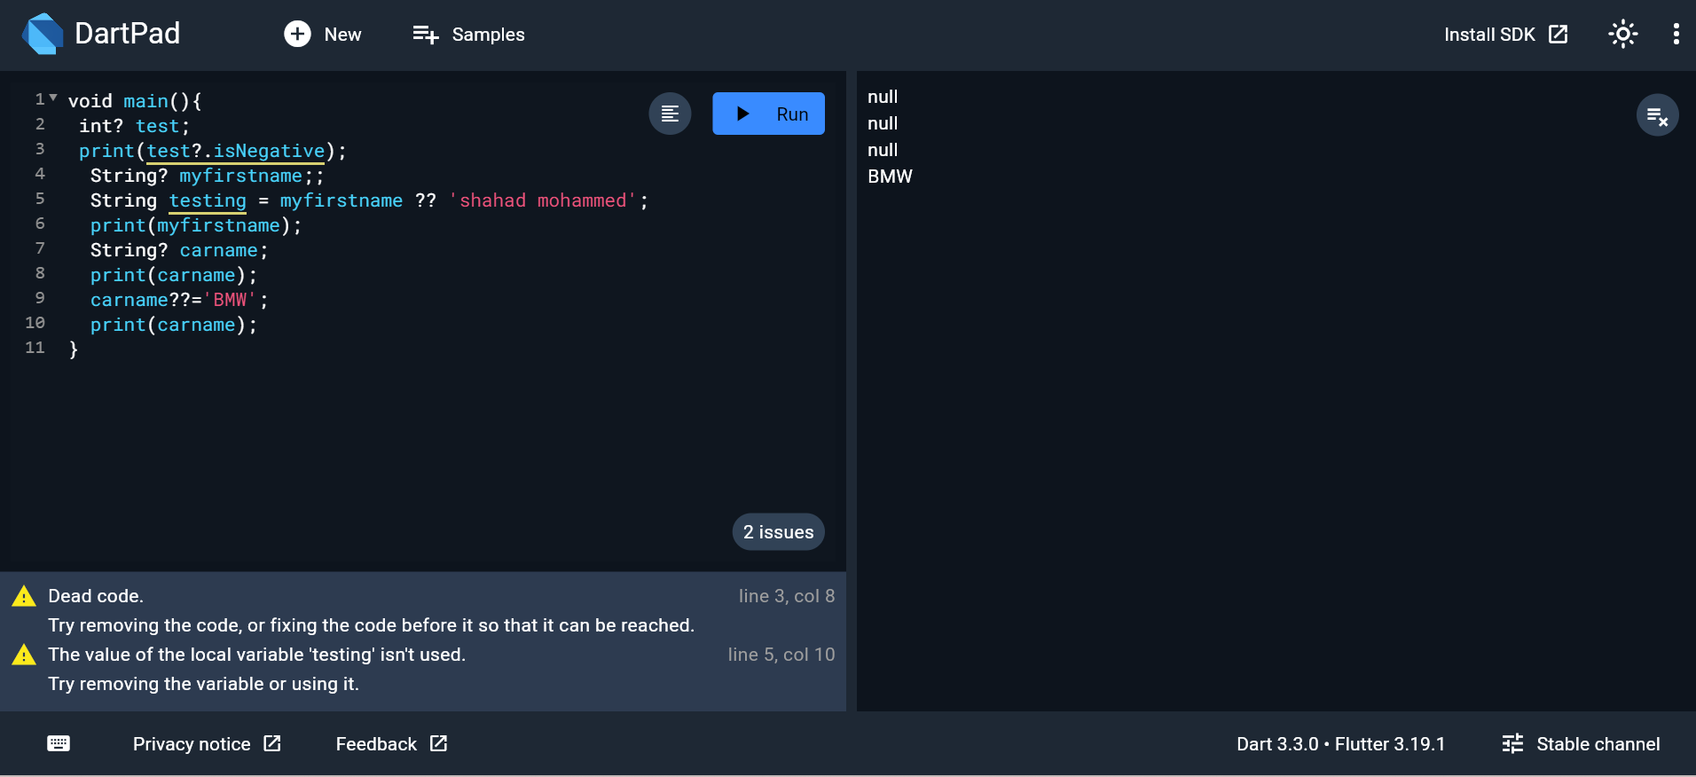

2.Write a Dart program and develop a function that takes a nullable integer parameter and returns a non-nullable integer. Handle null values appropriately within the function and explain your approach.

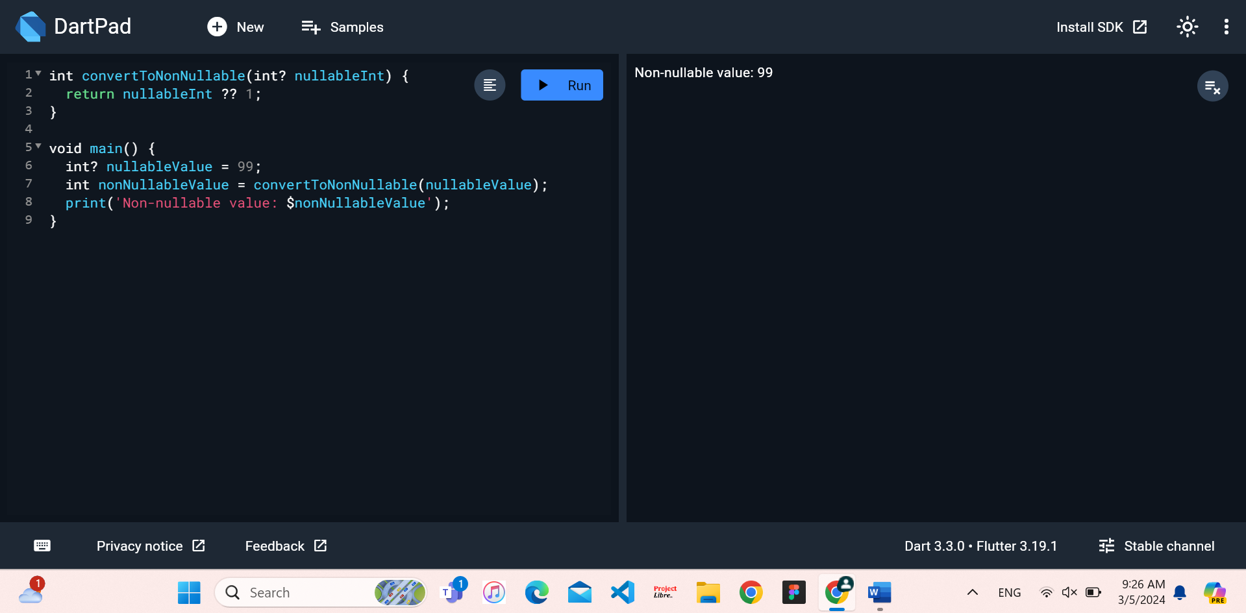

1. Create a Dart program that reads user input for a person's age and prints a customized message based on the input. Ensure the program handles null values and invalid input gracefully.

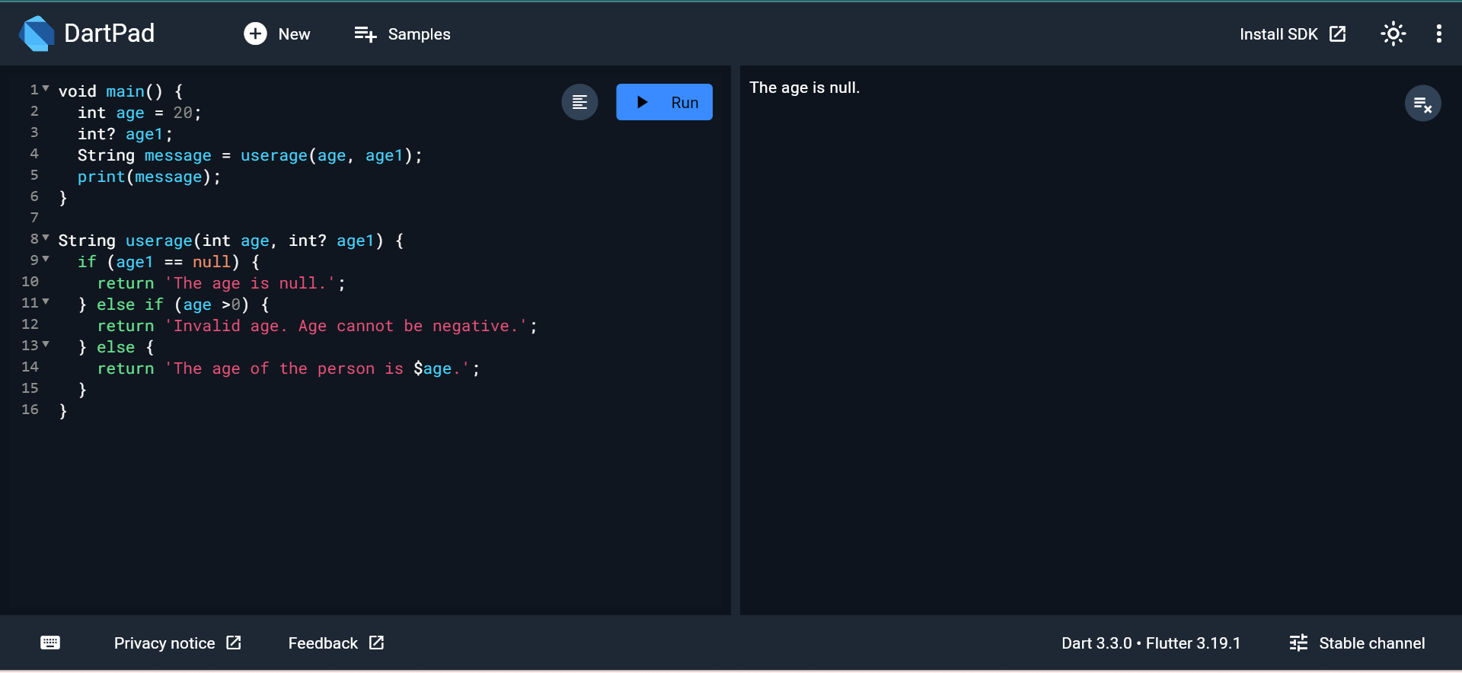

**Question** 3: Handling Null Values in Dart

**Objective**:

To delve deeper into advanced techniques for handling null values in Dart and practice implementing null-safe code patterns.

**Tasks**:

1.Write a Dart program that utilizes the **late** keyword and null assertion operator (!) to handle delayed initialization of non-nullable variables.

